Going Green – With Envy

W241 - Experiments and Causality

Ram Balasubramanian, Tarun Chopra, Cynthia Hu, Yang Yang Qian

**1 Executive Summary** **1**

**2 Introduction** **2**

2.1 Social Comparison Theory 3

**3 Experimental Design** **3**

3.1 Outcome Measure 4

3.2 Target Population 4

3.3 Experiment Duration 5

3.4 Treatment 5

3.5 Clustered Random Assignment 6

**4 Covariates** **7**

**5 Data Collection** **8**

**6 Analysis and Results** **8**

6.1 Exploratory Analysis 8

6.2 Covariate Balance Check 10

6.3 Treatment Effect 10

6.4 Missing Data 11

6.5 Power Analysis 11

**7 Conclusions** **12**

7.1 Limitations and Future Opportunities 12

# 

# 1 Executive Summary

The basic research question for our experiment was to find if we can improve recycling in the US by means of social comparison. The recycling rate (percent of total waste that is recycled) in the US is 35% (placing us at #25 in the world) compared to the #1 country in recycling - Germany at 65%. The experiment was conducted in two neighborhoods in Montgomery County, MD whose recycling rates was lower than average for the county. We randomly treated “non-recyclers” - those who are not currently participating in recycling in these two neighborhoods with a flyer that compared their neighborhood’s recycling rate to the county’s overall recycling rate. Based on our measurements, the treatment had a negative impact, i.e. participation rate at households receiving the treatment was 10% lower than the control group. This was counter to our expectations, however this effect is not statistically significant. In order to get more robust results, future experiments should consider a longer treatment period (with multiple treatments) and a larger sample.

# 2 Introduction

We live in a world where human population has grown steadily currently stands at 7.6 Billion. Addition of every single human-being to the planet adds significant waste over his or her lifetime. With the steady increase in population and the prevalence of certain societal factors like increase in wealth leading to more buying, development of new products and packaging that are not biodegradable, and lifestyle changes like reliance on fast-food consumption, are all leading to more and more waste being created in the world.

By 2100[1], the increasing global urban population will be producing three times as much waste at it does today. If the world keeps up with the current urbanization and population growth rate, the global waste generation is estimated to rise to 2.2 billion tons by 2025[2]. All this waste being produced has been having a grave and negative impact on the environment.

1. Generation of harmful chemical and greenhouse gases from landfill sites.
2. Effects of deforestation to habitat destruction and global warming.
3. Larger amounts of energy required to build new products from raw materials.

One way to combat the issue of increasing waste is through recycling - *the process of collecting and processing materials that would otherwise be thrown away as trash and turning them into new products*. In addition to benefiting the economy (according to 2016 Recycling Information Report[3], it was estimated that in 2007, activities related to recycling in US contributed to 757,000 jobs, $36.6 billion in wages and $6.7 billion in tax revenue), recycling impacts our environment positively by:

1. Reducing waste sent to landfills
2. Conservation of natural resources (wood, water, minerals), pollution by reducing the need for creation of new materials.
3. Savings in energy consumption by reusing existing products vs. building new ones.

Clearly recycling is a great way to arrest the negative impact to the environment resulting from increased consumption due to ever increasing population.

But not everyone recycles. According to a recent report[4] Germany ranks #1 on the list of countries with the highest recycling rate with 65% of its waste being recycled; The United States of America ranks #25 on that list with an overall recycling rate of 35%. How can we do better in the US?

## 2.1 Social Comparison Theory

In Psychology, motivation for individual action[5] has been well-studied. One way to motivate people is through Social Comparison Theory[6] - a theory first proposed by Leon Festinger, which states that we determine our personal worth based on how we stack up against others.

Our experiment is predicated on motivating individuals to act for social-good using social comparison.

# 3 Experimental Design

In this field experiment study, we intend to estimate the effect of social comparison on recycling. Many municipalities spend a lot of resources educating their residents on the benefits of recycling. In Montgomery County, MD (our test geography), there is an annual flyer that is mailed to every resident of the county informing them of the benefits of recycling and providing information on how and what to recycle. According to Alan Pultyniewicz the recycling coordinator for Montgomery County (MoCo), MD – current recycling rate [7]in MoCo is 61% with a goal of getting to 70% by 2020. While the county has engaged in a lot of education efforts to increase recycling (print ads, billboards, social media) , they don’t really have a good handle on the impact of these individual efforts. Participation rates vary by neighborhoods and in general there seem to be an economic divide with higher-income neighborhoods with higher participation (rate at which recycling material is put-out for pick up) than lower-income neighborhoods.

The field experiment in this study is an attempt to measure the impact of direct-communication (mail-in flyer) on recycling participation when the mailer includes a social comparison tactic.

## 3.1 Outcome Measure

Montgomery County has a data-based approach to their recycling program. As a result, they collect recycling data daily for each pick-up route (a pick-up route typically consists of 400-600 residential units). Ideally, we would have been able to use this data for our experiment, however, there are some challenges with the way the data is collected, stored and is made available by the county that required us to take a different approach for this experiment.

To fit the experiment to the resources available for this project, we decided to focus on a different outcome measure – “recycling participation” – essentially an indicator (1 or 0) for whether a household made recycling materials available for pick-up on the scheduled collection day for the neighborhood.

## 3.2 Target Population

Given that the recycling rate is already very high (61%) in MoCo, in order use resources more efficiently, it makes sense to target future efforts at increasing recycling rates to residents that are not currently participating in the recycling effort. So our target population is MoCo residents that are not currently participating in the recycle program.

Given the limitations of time and resources available for this field experiment project, we decided to collect a small sample of single family residents in MoCo that are non-participants in the recycling program. We did this by studying recycling patterns near one of the researcher’s home (a rather convenient sample), for several days and decided on a subset of two routes (RE13W02 and RE13H02) that had enough non-participating residents based on one week’s observation. There were 186 houses in these two routes (out of a total of 485 houses observed) that did not participate in the recycling program in the pre-treatment period.

## 3.3 Experiment Duration

We took one pre-treatment measurement of the outcome to help identify the sample of the target population we will be conducting our experiment on. We then randomly assigned some of these houses to our treatment group. We administered our treatment – which was a direct-mailed postcard (details below) with information about the extent of participation in the neighborhood compared to overall county statistics, along with other useful information on how and what to recycle. We measured the outcome (whether or not the households participated in recycling) one week after treatment. The timing of the measurements in shown in the table below:

|  |  |  |  |  |
| --- | --- | --- | --- | --- |
| 03/08/2014 | 03/14/2018 | 03/25/2018 | 04/04/2018 | 04/05/2018 |
| Pre-treatment | Pre-Treatment | Treatment | Post-Treatment | Post-Treatment |

## 3.4 Treatment

The flyer included benefits of recycling to the environment and information on how to recycle in Montgomery County through pictures on the front page. It had social comparison data on the back, highlighting the neighborhood’s recycling rate compared to the average recycling rate in the county and the county’s goal of getting to 70% by 2020.

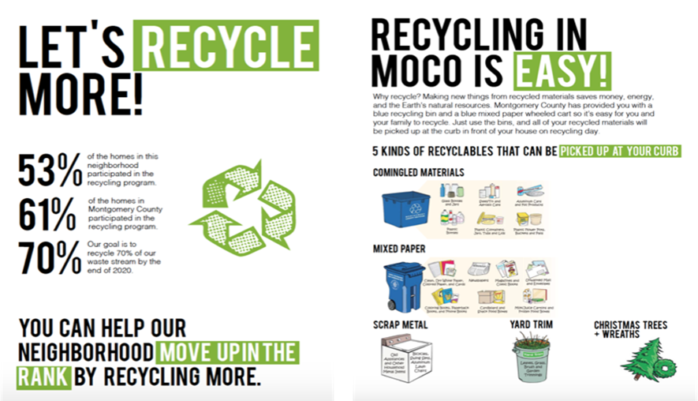

As recycling rules vary by county or state, we used the information from the county’s website and integrated all the information into the flyer with one style. While we designed the treatment to be as effective as possible (catchy colors, large font, post-card vs. envelop) to increase compliance (i.e. read the flyer), we realize that not all the houses assigned to treatment might have complied with our treatment. Ideally, we would have done a follow-up survey to identify the households that were assigned to treatment – to get a measure of whether they were actually “treated” i.e. read the postcard we sent them. Since we did not pursue the follow-up survey approach, our estimated treatment effect is an “intent to treat” measure and not the actual treatment effect. Since we do not have an estimate for the compliance rate, we cannot compute a Complier Average Causal Effect for the treatment either.

## 3.5 Clustered Random Assignment

Since neighbors may talk to each other (and observe each others’ actions) - it is possible that there might be some treatment spill-over if we assign houses in a neighborhood to different treatment conditions. Therefore, we conducted random assignment at street level - an entire street gets the same treatment condition. There are 25 streets in our sample, and we randomly assigned 13 of them to treatment group – (out of the 186 households selected for this experiment, there were 102 households assigned to treatment and 84 assigned to control). Please see the data flow chart below.



# 4 Covariates

There are several factors that could influence someone’s recycling behavior – belief that it matters, environmental awareness, social mores/peer-pressure, income, education level etc. Because of our experimental design (randomized control trial), these covariates are independent from the treatment assignment – therefore our treatment-estimates are unbiased. However, we might be able to get better precision on our treatment-estimate by using some of these covariates if they help explain some of the variance in the outcome measure. In reality, getting household level information for the metrics listed above is either unmeasurable or just difficult to obtain for this project. Instead, we used route number and created a new metric called neighbor-score in our analysis.

# 5 Data Collection

The outcome we were interested in is recycle participation i.e. did a household put out recycle materials for pick up or not. In order to select our target population (those that are currently non-participants), we did a pre-treatment measurement. We scouted several routes before deciding on two that had enough non-participants to execute our experiment.

To ensure that we had the most accurate participation data, we had to time the data collection right before the regular pick-up times. The actual data collection was done through a video recording using a GoPro camera mounted on a car-window and driving along the collection route. Our preliminary scouting runs helped us fine-tune this data collection method - and we ended up with a combination of video recording as well as audio recording where the researcher read out the house number and the bin-status as they drove along the recycle route.

This experiment study uses double blindness. First, the subjects did not know that they were participating in the experiment. Second, the researcher who collected the data (both pre-treatment and post-treatment) was not made aware of the treatment assignment which was conducted by a different researcher.

# 6 Analysis and Results

## 6.1 Exploratory Analysis

Below exploratory charts are for the 186 houses in the experiment. Most streets have less than 20 houses per street, though we have one outlier with 40 houses "Potomac Oaks Drive". There are more houses on route “RE13W02” where recycling bins are picked up Wednesdays versus route “RE13H02” where the collection day is Thursday. Overall, 36% of households put their recycle bins for pickup during the week post treatment.

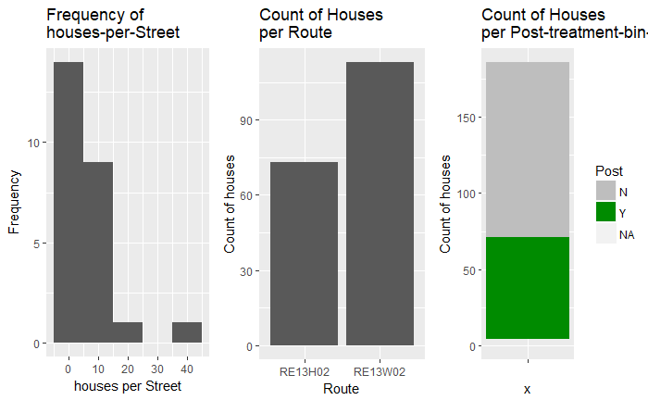

We suppose that a household’s participation in recycling might be influenced by their immediate neighbors’ participation i.e. if one’s neighbors recycle, perhaps due to peer pressure, one might be more likely to recycle. In order get better precision for our treatment effect estimate, we created a new metric “neighbor-score” that captures this effect. The neighbor-score for a house is the fraction of neighboring houses (defined as being within 60 meters of the house) that participate in recycling. We see that for the two neighborhoods we chose to conduct our experiments, houses on average tend to be among neighbors that are rather favorable to recycling (median ratio is 0.6). The median score of the control group is higher than the treatment group. We conducted a statistical test to measure if this difference significant.

.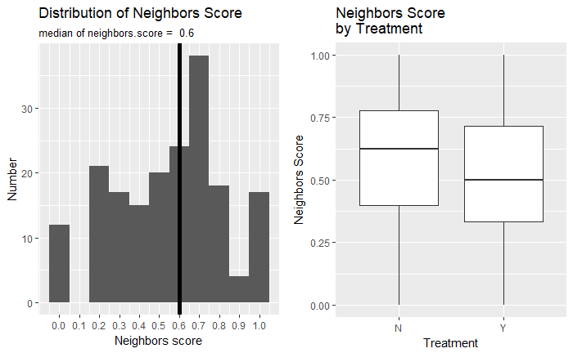

## 6.2 Covariate Balance Check

In order to verify that our randomization process was truly random, we compared a short and long model where the predicted variable was the treatment assignment and the predictors were the covariates. We got a low p-value of 0.0001897 from the ANOVA test, indicating that we can reject the NULL hypothesis that all the coefficients in the regression are zero.

Unfortunately, it looks like we didn't quite split our assignment to treatment and control fairly with regards to these covariates. But that is explainable, because our design randomized by street, and did not actively balance across covariates of neighbors score or street score. We will include these covariates in our treatment estimate computation, so that we can get an estimate of the effect conditional on these.

Analysis of Variance Table

Model 1: D ~ 1

Model 2: D ~ 1 + street.score + neighbors.score + wed

Res.Df RSS Df Sum of Sq Pr(>Chi)

1 185 46.065

2 182 41.552 3 4.5128 0.0001897 ***

## 6.3 Treatment Effect

We used regression to estimate treatment effect using two models. In both models, “Post.bin” - which is an indicator for whether a household put out a recycling bin during the post-treatment observation is our outcome variable.

The first model (labeled “Short”) showed a non-statistically significant negative treatment effect -0.10, with a confidence interval of (-0.24, 0.04) which includes zero i.e. the recycle participation rate among houses that received our treatment was 10% lower than those that did not receive our treatment. The intercept of 0.425 is simply the fraction of households in the control group that put a bin out for recycling.

In order to get more precision on our treatment effect - we included the covariates (specifically the Pickup day and the neighbor-score described above) labeled “Long” in the table below. While this longer model provided a more precise estimate, it continued to not be statistically significant. Based on the long model our estimated treatment effect is -0.065, with a confidence interval of (-0.20, 0.08) which includes zero.

Therefore, we did not find any statistically significant results for our treatment and we cannot reject our null hypothesis that our treatment had no effect.

Estimated Model Parameters:

|  |  |  |
| --- | --- | --- |
| N = 182 | **Short** | **Long** |
| **Treatment** | -0.101 (0.095) | -0.065 (0.070) |
| **Neighbors Score** |  | 0.094 (0.213) |
| **Pickup (Wed)** |  | 0.185*** (0.071) |
| **Constant** | 0.425*** (0.070) | 0.242** (0.118) |
| **R2** | 0.011 | 0.05 |
| *p<0.1; **p<0.05; ***p<0.01 | | |

## 6.4 Missing Data

There were 5 missing records due to measurement errors and we performed boundary analysis for the missing data. If we assume they all would NOT have put out a bin, using the long model the treatment effect would have been -0.04 (standard error: 0.08). If we assumed they would have put out a bin, using the long model, the treatment effect would have been -0.09 (standard error: 0.07). Neither were statistically significant.

## 6.5 Power Analysis

Ideally we would have conducted this analysis pre-experiment. But now that we have some sense for the magnitude of the treatment effect, we wanted to see how large the sample size ought to be for future experiments to be able to detect a treatment effect if one existed. Using sample means of control group and treatment group and effect size of (0.1) we simulated the experiment 1000 times. Given our experiment sample size, the power is only 27.4% i.e. we only had a 27% chance of detecting a true treatment effect of the magnitude we estimated. To achieve 80% power with the same effect size, we would have needed a sample size of around 750 homes.

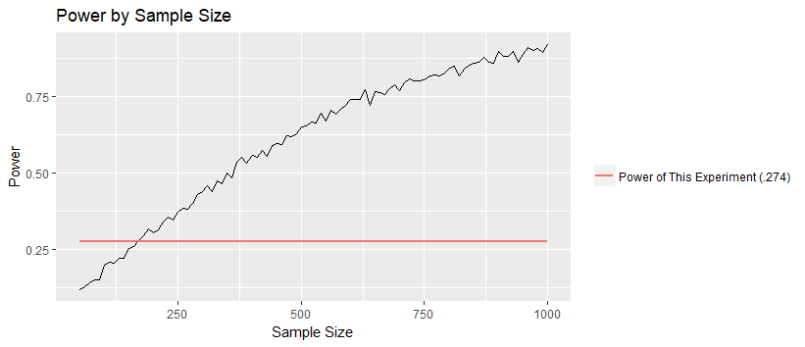

# 7 Conclusions

From this sample data we detected -0.1 effect size but it’s not significant at 5% level. Therefore, there is no evidence showing that we changed people’s recycling behavior using our treatment.

## 7.1 Limitations and Future Opportunities

We all know that it’s difficult to change people’s behavior and form a new habit, such as recycling. Ideally, we would treat our subjects several times, such as quarterly or even monthly to keep reminding people of the benefits of recycling and measure the outcome variables for a longer period of time after the treatment to detect the long-term effect. Due to limited resources and time, we only had the opportunity to treat once and measure the immediate effect of that treatment in this project.

Another limitation of this study is that we used participation rate as an outcome measure for our treatment. A different measure, such as recycling rate (recycled material weight divided by the weight of trash and recycled material) could possibly be better suited to include the impact of the treatment on houses that are currently participating in recycling.

1. http://www.worldbank.org/en/news/feature/2013/10/30/global-waste-on-pace-to-triple
2. http://www.globalwastemanagementconference.com/
3. https://www.epa.gov/sites/production/files/2017-05/documents/final_2016_rei_report.pdf
4. https://www.weforum.org/agenda/2017/12/germany-recycles-more-than-any-other-country/
5. https://www.psychologytoday.com/us/articles/201701/the-mystery-motivation
6. https://www.psychologytoday.com/us/basics/social-comparison-theory
7. https://www.montgomerycountymd.gov/sws/